#### Overview

Fabrikam, Inc. is an engineering company that has offices throughout Europe. The company has a main office in London and three branch offices in Amsterdam, Berlin, and Rome.

#### Existing Environment

**Active Directory Environment**

The network contains two Active Directory forests named corp.fabrikam.com and rd.fabrikam.com. There are no trust relationships between the forests.

Corp.fabrikam.com is a production forest that contains identities used for internal user and computer authentication.

Rd.fabrikam.com is used by the research and development (R&D) department only.

#### Network Infrastructure

Each office contains at least one domain controller from the corp.fabrikam.com domain. The main office contains all the domain controllers for the rd.fabrikam.com forest.

All the offices have a high-speed connection to the Internet.

An existing application named WebApp1 is hosted in the data center of the London office. WebApp1 is used by customers to place and track orders.

WebApp1 has a web tier that uses Microsoft Internet Information Services (IIS) and a database tier that runs Microsoft SQL Server 2016. The web tier and the database tier are deployed to virtual machines that run on Hyper-V.

The IT department currently uses a separate Hyper-V environment to test updates to WebApp1.

Fabrikam purchases all Microsoft licenses through a Microsoft Enterprise Agreement that includes Software Assurance.

#### Problem Statements

The use of Web App1 is unpredictable. At peak times, users often report delays. At other times, many resources for WebApp1 are underutilized.

#### Requirements Planned Changes

Fabrikam plans to move most of its production workloads to Azure during the next few years.

As one of its first projects, the company plans to establish a hybrid identity model, facilitating an upcoming Microsoft Office 365 deployment.

All R&D operations will remain on-premises.

Fabrikam plans to migrate the production and test instances of WebApp1 to Azure.

#### Technical Requirements

Fabrikam identifies the following technical requirements:

Web site content must be easily updated from a single point.

User input must be minimized when provisioning new app instances.

Whenever possible, existing on-premises licenses must be used to reduce cost. Users must always authenticate by using their corp.fabrikam.com UPN identity. Any new deployments to Azure must be redundant in case an Azure region fails.

Whenever possible, solutions must be deployed to Azure by using platform as a service (PaaS).

An email distribution group named IT Support must be notified of any issues relating to the directory synchronization services.

Directory synchronization between Azure Active Directory (Azure AD) and corp.fabrikam.com must not be affected by a link failure between Azure and the on-premises network.

#### Database Requirements

Fabrikam identifies the following database requirements:

Database metrics for the production instance of WebApp1 must be available for analysis so that database administrators can optimize the performance settings.

To avoid disrupting customer access, database downtime must be minimized when databases are migrated.

Database backups must be retained for a minimum of seven years to meet compliance requirements.

#### Security Requirements

Fabrikam identifies the following security requirements:

Company information including policies, templates, and data must be inaccessible to anyone outside the

company.

Users on the on-premises network must be able to authenticate to corp.fabrikam.com if an Internet link fails.

Administrators must be able authenticate to the Azure portal by using their corp.fabrikam.com credentials.

All administrative access to the Azure portal must be secured by using multi-factor authentication. The testing of WebApp1 updates must not be visible to anyone outside the company.

#### QUESTION 1

What should you include in the identity management strategy to support the planned changes?

1. Move all the domain controllers from corp.fabrikam.com to virtual networks in Azure.
2. Deploy domain controllers for corp.fabrikam.com to virtual networks in Azure.
3. Deploy a new Azure AD tenant for the authentication of new R&D projects.
4. Deploy domain controllers for the rd.fabrikam.com forest to virtual networks in Azure.

#### Correct Answer: B Section: (none) Explanation

**Explanation/Reference:**

Explanation:

Directory synchronization between Azure Active Directory (Azure AD) and corp.fabrikam.com must not be affected by a link failure between Azure and the on-premises network. (This requires domain controllers in Azure)

Users on the on-premises network must be able to authenticate to corp.fabrikam.com if an Internet link fails. (This requires domain controllers on-premises)

#### QUESTION 2

HOTSPOT

To meet the authentication requirements of Fabrikam, what should you include in the solution? To answer, select the appropriate options in the answer area.

**NOTE:** Each correct selection is worth one point.

#### Hot Area

**:**

**Correct Answer:**

**Answer is 1,1,0**

You need to recommend a solution to meet the database retention requirement. What should you recommend?

1. Configure geo-replication of the database
2. Configure Azure Site Recovery
3. Configure a long-term retention policy for the database
4. Use automatic Azure SQL Database backups

Correct Answer: C

You are evaluating the components of the migration to Azure that require you to provision an Azure Storage account.

For each of the following statements, select Yes if the statement is true. Otherwise, select No.

**NOTE:** Each correct selection is worth one point.

#### Hot Area:

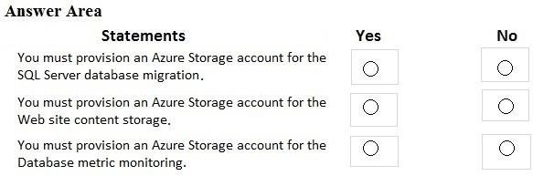

**Correct Answer:**

No, No, Yes

**Section: (none) Explanation**

**Explanation/Reference:**

**QUESTION 2**

You need to recommend a strategy for migrating the database content of WebApp1 to Azure. What should you include in the recommendation?

1. Use Azure Site Recovery to replicate the SQL servers to Azure
2. Use SQL Server transactional replication
3. Copy the VHD that contains the Azure SQL database files to Azure Blob storage
4. Copy the BACPAC file that contains the Azure SQL database files to Azure Blob storage

#### Correct Answer: C Section: (none) Explanation

**Explanation/Reference:**

Explanation:

Before you upload a Windows virtual machine (VM) from on-premises to Azure, you must prepare the virtual hard disk (VHD or VHDX).

Scenario: WebApp1 has a web tier that uses Microsoft Internet Information Services (IIS) and a database tier that runs Microsoft SQL Server 2016. The web tier and the database tier are deployed to virtual machines that run on Hyper-V.

Reference:

https://docs.microsoft.com/en-us/azure/virtual-machines/windows/prepare-for-upload-vhd-image

#### QUESTION 3

You need to recommend a strategy for the web tier of WebApp1. The solution must minimize costs. What should you recommend?

1. Configure the Scale Up settings for a web app
2. Create a runbook that resizes virtual machines automatically to a smaller size outside of business hours
3. Deploy a virtual machine scale set that scales out on a 75 percent CPU threshold
4. Configure the Scale Out settings for a web app

Correct Answer: D

You need to recommend a notification solution for the IT Support distribution group. What should you include in the recommendation?

1. Azure Network Watcher
2. an action group
3. a SendGrid account with advanced reporting
4. Azure AD Connect Health

Correct Answer: D

You need to recommend a notification solution for the IT Support distribution group. What should you include in the recommendation?

* A. Azure Network Watcher
* B. an action group
* C. a SendGrid account with advanced reporting
* D. Azure AD Connect Health

**Answer-**

**C. Azure AD Connect Health**

To meet the authentication requirements of Fabrikam, what should you include in the solution? To answer, select the appropriate options in the answer area.

NOTE: Each correct selection is worth one point.

**An**

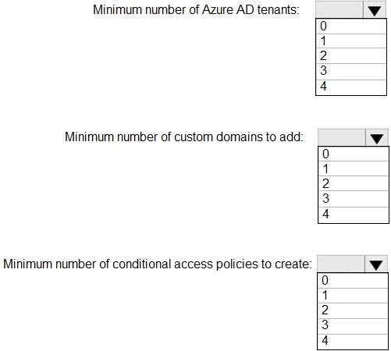

**swe**

1

1

[*Visit us athttps://www.examsboost.com/test/az-304/*](https://www.examsboost.com/test/az-304/)

0

**Question: 3**

You need to recommend a strategy for migrating the database content of WebApp1 to Azure. What should you include in the recommendation?

1. Use Azure Site Recovery to replicate the SQL servers to Azure.
2. Use SQL Server transactional replication.
3. Copy the BACPAC file that contains the Azure SQL database file to Azure Blob storage.
4. Copy the VHD that contains the Azure SQL database files to Azure Blob storage

**Answer: D**

Explanation:

Before you upload a Windows virtual machine (VM) from on-premises to Azure, you must prepare the virtual hard disk (VHD or VHDX).

Scenario: WebApp1 has a web tier that uses Microsoft Internet Information Services (IIS) and a database tier that runs Microsoft SQL Server 2016. The web tier and the database tier are deployed to virtual machines that run on Hyper-V.

Reference:

https://docs.microsoft.com/en-us/azure/virtual-machines/windows/prepare-for-upload-vhd-image

**Question: 4**

You need to recommend a strategy for the web tier of WebApp1. The solution must minimize What should you recommend?

### Create a runbook that resizes virtual machines automatically to a smaller size outside of business hours.

1. Configure the Scale Up settings for a web app.

[*Visit us athttps://www.examsboost.com/test/az-304/*](https://www.examsboost.com/test/az-304/)

### Deploy a virtual machine scale set that scales out on a 75 percent CPU threshold.

1. Configure the Scale Out settings for a web app.

**Answer: D**

**Question: 7**

What should you include in the identity management strategy to support the planned changes?

### Move all the domain controllers from corp.fabrikam.com to virtual networks in Azure.

1. Deploy domain controllers for corp.fabrikam.com to virtual networks in Azure.
2. Deploy a new Azure AD tenant for the authentication of new R&D projects.
3. Deploy domain controllers for the rd.fabrikam.com forest to virtual networks in Azure.

**Answer: B**

Explanation:

Directory synchronization between Azure Active Directory (Azure AD) and corp.fabrikam.com must not be affected by a link failure between Azure and the on-premises network. (This requires domain controllers in Azure)

Users on the on-premises network must be able to authenticate to corp.fabrikam.com if an Internet link fails. (This requires domain controllers on-premises)

**Question: 8**

You are evaluating the components of the migration to Azure that require you to provision an Azure Storage account.

For each of the following statements, select Yes if the statement is true. Otherwise, select No. NOTE: Each correct selection is worth one point.

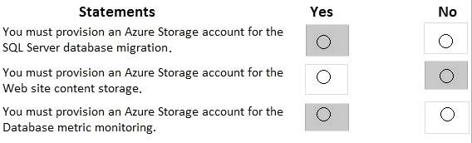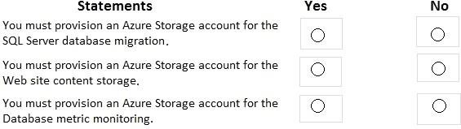

**Answe**

**Question: 9**

You need to recommend a notification solution for the IT Support distribution group. What should you include in the recommendation?

### Azure Network Watcher

[*Visit us athttps://www.examsboost.com/test/az-304/*](https://www.examsboost.com/test/az-304/)

### an action group

1. a SendGrid account with advanced reporting
2. Azure AD Connect Health

**Answer: D**

References:

https://docs.microsoft.com/en-us/azure/active-directory/hybrid/how-to-connect-health-operations

#### Overview

Contoso, Ltd. is a US-based financial services company that has a main office in New York and a branch office in San Francisco.

#### Existing Environment Payment Processing System

Contoso hosts a business-critical payment processing system in its New York data center. The system has three tiers: a front-end web app, a middle-tier web API, and a back-end data store implemented as a Microsoft SQL Server 2014 database. All servers run Windows Server 2012 R2.

The front-end and middle-tier components are hosted by using Microsoft Internet Information Services (IIS). The application code is written in C# and ASP.NET. The middle-tier API uses the Entity Framework to communicate to the SQL Server database. Maintenance of the database is performed by using SQL Server Agent jobs.

The database is currently 2 TB and is not expected to grow beyond 3 TB.

The payment processing system has the following compliance-related requirements:

Encrypt data in transit and at rest. Only the front-end and middle-tier components must be able to access the encryption keys that protect the data store.

Keep backups of the data in two separate physical locations that are at least 200 miles apart and can be restored for up to seven years.

Support blocking inbound and outbound traffic based on the source IP address, the destination IP address, and the port number.

Collect Windows security logs from all the middle-tier servers and retain the logs for a period of seven years.

Inspect inbound and outbound traffic from the front-end tier by using highly available network appliances.

Only allow all access to all the tiers from the internal network of Contoso.

Tape backups are configured by using an on-premises deployment of Microsoft System Center Data Protection Manager (DPM), and then shipped offsite for long term storage.

#### Historical Transaction Query System

Contoso recently migrated a business-critical workload to Azure. The workload contains a .NET web service for querying the historical transaction data residing in Azure Table Storage. The .NET web service is accessible from a client app that was developed in-house and runs on the client computers in the New York office. The data in the table storage is 50 GB and is not expected to increase.

#### Current Issues

The Contoso IT team discovers poor performance of the historical transaction query system, at the queries frequently cause table scans.

#### Requirements Planned Changes

Contoso plans to implement the following changes:

Migrate the payment processing system to Azure.

Migrate the historical transaction data to Azure Cosmos DB to address the performance issues.

#### Migration Requirements

Contoso identifies the following general migration requirements:

Infrastructure services must remain available if a region or a data center fails. Failover must occur without any administrative intervention.

Whenever possible, Azure managed services must be used to minimize management overhead. Whenever possible, costs must be minimized.

Contoso identifies the following requirements for the payment processing system:

If a data center fails, ensure that the payment processing system remains available without any administrative intervention. The middle-tier and the web front end must continue to operate without any additional configurations.

Ensure that the number of compute nodes of the front-end and the middle tiers of the payment processing system can increase or decrease automatically based on CPU utilization.

Ensure that each tier of the payment processing system is subject to a Service Level Agreement (SLA) of 99.99 percent availability.

Minimize the effort required to modify the middle-tier API and the back-end tier of the payment processing system.

Payment processing system must be able to use grouping and joining tables on encrypted columns. Generate alerts when unauthorized login attempts occur on the middle-tier virtual machines.

Ensure that the payment processing system preserves its current compliance status. Host the middle tier of the payment processing system on a virtual machine.

Contoso identifies the following requirements for the historical transaction query system: Minimize the use of on-premises infrastructure services.

Minimize the effort required to modify the .NET web service querying Azure Cosmos DB. Minimize the frequency of table scans.

If a region fails, ensure that the historical transaction query system remains available without any administrative intervention.

#### Information Security Requirements

The IT security team wants to ensure that identity management is performed by using Active Directory. Password hashes must be stored on-premises only.

Access to all business-critical systems must rely on Active Directory credentials. Any suspicious authentication attempts must trigger a multi-factor authentication prompt automatically. Legitimate users must be able to authenticate successfully by using multi-factor authentication.

#### QUESTION 1

You need to recommend a solution for implementing the back-end tier of the payment processing system in

Azure.

What should you include in the recommendation?

1. an Azure SQL Database managed instance
2. a SQL Server database on an Azure virtual machine
3. an Azure SQL Database single database
4. an Azure SQL Database elastic pool

#### Correct Answer: C Section: (none) Explanation

**Explanation/Reference:**

**QUESTION 2**

You need to recommend a solution for protecting the content of the payment processing system. What should you include in the recommendation?

1. Transparent Data Encryption (TDE)
2. Azure Storage Service Encryption
3. Always Encrypted with randomized encryption
4. Always Encrypted with deterministic encryption

#### Correct Answer: D Section: (none) Explanation

**Explanation/Reference:**

**QUESTION 3**

HOTSPOT

You need to recommend a solution for the data store of the historical transaction query system.

What should you include in the recommendation? To answer, select the appropriate options in the answer area.

**NOTE:** Each correct selection is worth one point.

#### ot Area:

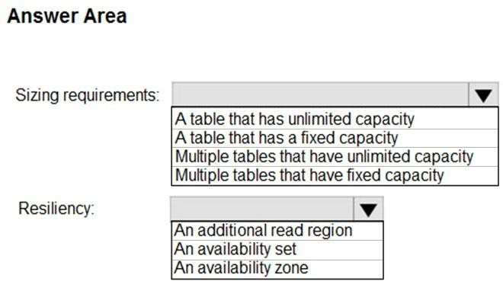

**Correct Answer:**

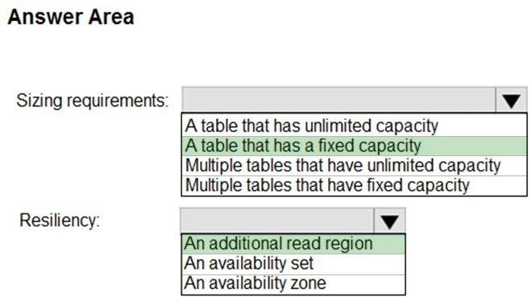

**Section: (none) Explanation**

**Explanation/Reference:**

#### QUESTION 1

You need to recommend a solution for implementing the back-end tier of the payment processing system in

Azure.

What should you include in the recommendation?

1. an Azure SQL Database managed instance
2. a SQL Server database on an Azure virtual machine
3. an Azure SQL Database single database
4. an Azure SQL Database elastic pool

#### Correct Answer: C Section: (none) Explanation

**Explanation/Reference:**

**QUESTION 2**

You need to recommend a solution for protecting the content of the payment processing system. What should you include in the recommendation?

1. Transparent Data Encryption (TDE)
2. Azure Storage Service Encryption
3. Always Encrypted with randomized encryption
4. Always Encrypted with deterministic encryption

#### Correct Answer: D Section: (none) Explanation

**Explanation/Reference:**

**QUESTION 3**

HOTSPOT

You need to recommend a solution for the data store of the historical transaction query system.

What should you include in the recommendation? To answer, select the appropriate options in the answer area.

**NOTE:** Each correct selection is worth one point.

#### ot Area:



**Correct Answer:**



**Section: (none) Explanation**

**Explanation/Reference:**

#### QUESTION 1

You need to recommend a backup solution for the data store of the payment processing system.

What should you include in the recommendation?

1. Microsoft System Center Data Protection Manager (DPM)
2. Azure SQL long-term backup retention
3. Azure Backup Server
4. a Recovery Services vault
5. Azure Managed Disks

#### Correct Answer: B Section: (none) Explanation

**Explanation/Reference:**

Reference:

https://docs.microsoft.com/en-us/azure/sql-database/sql-database-long-term-backup-retention-configure

#### QUESTION 2

You need to recommend a disaster recovery solution for the back-end tier of the payment processing system.

What should you include in the recommendation?

1. Always On Failover Cluster Instances
2. Azure Site Recovery
3. an auto-failover group
4. geo-redundant database backups

#### Correct Answer: C Section: (none) Explanation

**Explanation/Reference:**

Explanation:

Scenario:

The back-end data store is implemented as a Microsoft SQL Server 2014 database.

If a data center fails, ensure that the payment processing system remains available without any administrative intervention.

Note: Auto-failover groups is a SQL Database feature that allows you to manage replication and failover of a group of databases on a SQL Database server or all databases in a managed instance to another region. It is a declarative abstraction on top of the existing active geo-replication feature, designed to simplify deployment and management of geo-replicated databases at scale.

Reference:

https://docs.microsoft.com/en-us/azure/sql-database/sql-database-auto-failover-group

#### QUESTION 3

You need to recommend a high-availability solution for the middle tier of the payment processing system. What should you include in the recommendation?

1. the Isolated App service plan
2. availability zones
3. an availability set
4. the Premium App Service plan

#### Correct Answer: B Section: (none) Explanation

#### QUESTION 1

You need to recommend a compute solution for the middle tier of the payment processing system. What should you include in the recommendation?

1. Azure Kubernetes Service (AKS)
2. virtual machine scale sets
3. availability sets
4. Function App

#### Correct Answer: B Section: (none) Explanation

**Explanation/Reference:**

**QUESTION 2**

You need to recommend a solution for the network configuration of the front-end tier of the payment processing.

What should you include in the recommendation?

1. Azure Application Gateway
2. Traffic Manager
3. a Standard Load Balancer
4. a Basic load Balancer

#### Correct Answer: C Section: (none) Explanation

You need to recommend a backup solution for the data store of the payment processing. What should you include in the recommendation?

### Microsoft System Center Data Protection Manager (DPM)

1. long-term retention
2. a Recovery Services vault
3. Azure Backup Server

**Answer: B**

References:

[*Visit us athttps://www.examsboost.com/test/az-304/*](https://www.examsboost.com/test/az-304/)

https://docs.microsoft.com/en-us/azure/sql-database/sql-database-long-term-backup-retention- configure

**Question: 11**

You need to recommend a solution for protecting the content of the back-end tier of the payment processing system.

What should you include in the recommendations?

### Always Encrypted with deterministic encryption

1. Transparent Date Encryption (TDE)
2. Azure Storage Service Encryption
3. Always Encrypted with randomized encryption

**Answer: A**

**Question: 12**

You need to recommend a solution for the user at Contoso to authenticate to the cloud-based sconces and the Azure AD-integrated application. What should you include in the recommendation? To answer, select the appropriate options in the answer area.

NOTE: Each correct selection is worth one point.

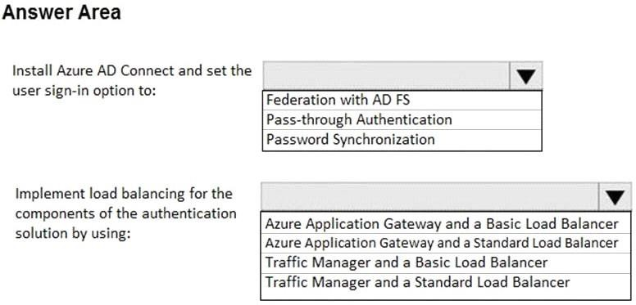

**Answe**

[*Visit us athttps://www.examsboost.com/test/az-304/*](https://www.examsboost.com/test/az-304/)

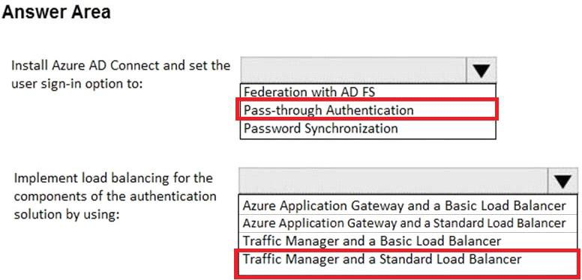

**Question: 13**

You need to recommend a solution for data of the historical transaction query system.

What should you include in the recommendation? To answer, Select the appropriate or options in the answer area.

NOTE: Each correct selection is worth one point

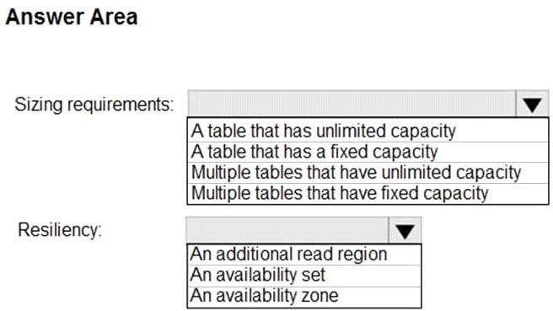

**Answe**

[*Visit us athttps://www.examsboost.com/test/az-304/*](https://www.examsboost.com/test/az-304/)

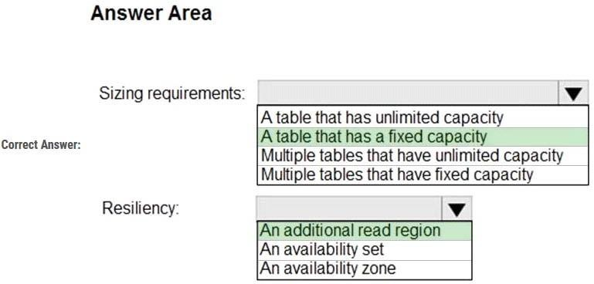

**Question: 14**

You need to recommend a solution for the network configuration of the front-end tier of the payment processing. What should you include in the recommendation?

### Azure Application Gateway

1. Traffic Manager
2. a Standard Load Balancer
3. a Basic load Balancer

**Answer: C**

Explanation:

Scenario:

Ensure that the number of compute nodes of the front-end and the middle tiers of the payment processing system can increase or decrease automatically based on CPU utilization.

Ensure that each tier of the payment processing system is subject to a Service Level Agreement (SLA) of

99.99 percent availability.

With Azure Load Balancer, you can scale your applications and create high availability for your services. Load Balancer supports inbound and outbound scenarios, provides low latency and high throughput, and scales up to millions of flows for all TCP and UDP applications.

Azure Load Balancer is available in two SKUs: Basic and Standard. There are differences in scale, features, and pricing. Standard SLA guarantees a 99.99% for data path with two healthy virtual machines. Basic SLA does not exist.

Reference:

https://docs.microsoft.com/en-us/azure/load-balancer/load-balancer-overview

**Question: 15**

[*Visit us athttps://www.examsboost.com/test/az-304/*](https://www.examsboost.com/test/az-304/)

You need to recommend a solution for the collection of security logs the middle tier of the payment processing system.

What should you include in the recommendation?

### Azure Notification Hubs

1. the Azure Diagnostics agent
2. Azure Event Hubs
3. the Azure Log Analytics agent

**Answer: D**

References:

https://docs.microsoft.com/en-us/azure/azure-monitor/platform/diagnostics-extension-overview

**Question: 17**

You need to recommend a solution for configuring the Azure Multi-Factor Authentication (MFA) settings. What should you include in the recommendation? To answer, select the appropriate options in the answer area.

NOTE: Each correct selection is worth one point.

[*Visit us athttps://www.examsboost.com/test/az-304/*](https://www.examsboost.com/test/az-304/)

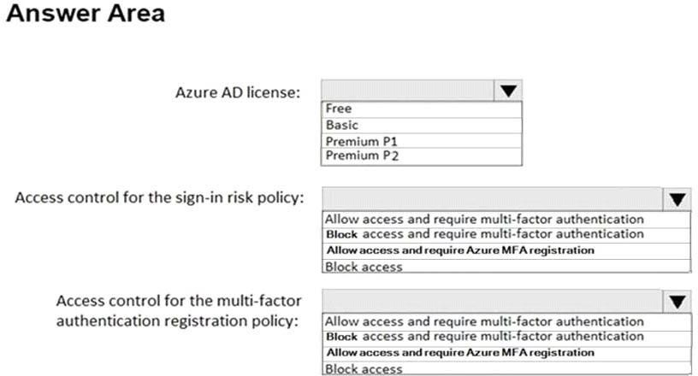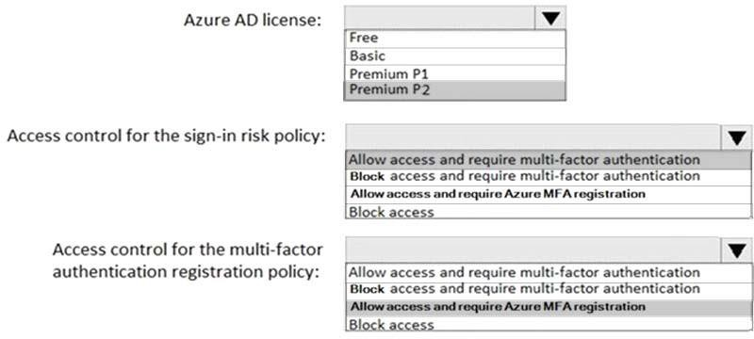

**Answe**

References:

https://docs.microsoft.com/en-us/azure/active-directory/identity-protection/howto-sign-in-risk-policy https://docs.microsoft.com/en-us/azure/active-directory/identity-protection/howto-mfa-policy

**Question: 18**

You need to design a solution for securing access to the historical transaction data.

What should you include in the solution? To answer, select the appropriate options in the answer area. NOTE: Each correct selection is worth one point.

[*Visit us athttps://www.examsboost.com/test/az-304/*](https://www.examsboost.com/test/az-304/)

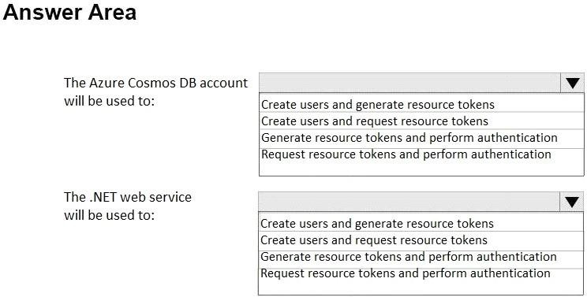

**Answer:**

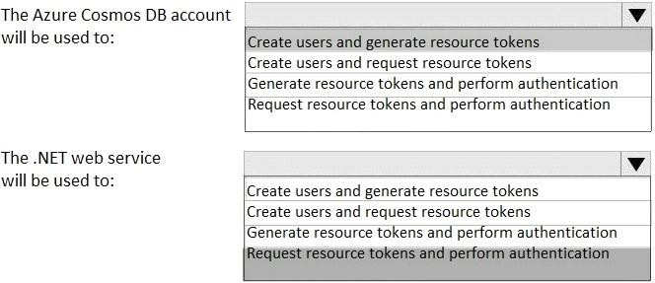

**Question: 19 – duplicate question - question 1 – page 75**

You need to recommend a solution for implementing the back-end tier of the payment processing system in Azure.

What should you include in the recommendation?

### an Azure SQL Database managed instance

1. a SQL Server database on an Azure virtual machine
2. an Azure SQL Database single database
3. an Azure SQL Database elastic pool

[*Visit us athttps://www.examsboost.com/test/az-304/*](https://www.examsboost.com/test/az-304/)

**Answer: C**

**Question: 21**

You need to recommend a compute solution for the middle tier of the payment processing system. What should you include in the recommendation?

### Azure Kubernetes Service (AKS)

1. virtual machine scale sets
2. availability sets
3. App Service Environments (ASEs)

**Answer: B**

**Question: 22 duplicate question question 2 page no 76**

You need to recommend a solution for protecting the content of the payment processing system. What should you include in the recommendation?

### Transparent Data Encryption (TDE)

1. Azure Storage Service Encryption
2. Always Encrypted with randomized encryption
3. Always Encrypted with deterministic encryption

**Answer: D**

[*Visit us athttps://www.examsboost.com/test/az-304/*](https://www.examsboost.com/test/az-304/)

**Question: 24**

You need to recommend a solution for the users at Contoso to authenticate to the cloud-based services and the Azure AD-integrated applications.

What should you include in the recommendation? To answer, select the appropriate options in the answer area.

NOTE: Each correct selection is worth one point.

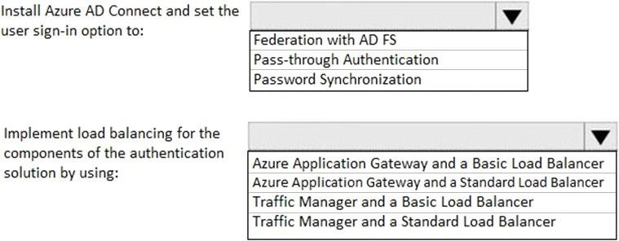

**Answe**

